* **Python 3.8.10을 검색하여 다운로드하고 인스톨하기(**[**python-3810/**](https://www.python.org/downloads/release/python-3810/)**)**

1. 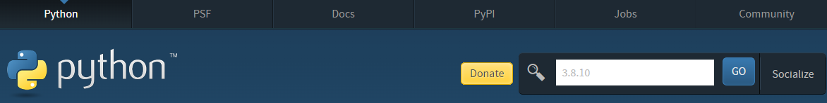
2. 
3. 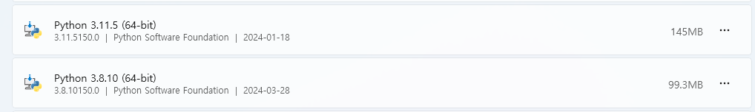

* **VS code에서 “data_mgt”폴더 만들고 open folder >> Python버젼 3.810 가상환경 “mae_ai”를 만들고 mage-ai 패키지 설치 후 mage start spring**

1. C:\data_mgt>
2. C:\data_mgt>pip install virtualenv
3. C:\data_mgt>virtualenv mage --python=3.8.10
4. C:\data_mgt>python –V
5. C:\data_mgt>cd mage
6. C:\data_mgt\mage>Scripts\activatepip
7. (mage) C:\data_mgt\mage>pip install mage-ai
   1. Github >> ([pip install mage-ai](https://github.com/mage-ai/mage-ai))
8. (mage) C:\data_mgt\mage>pip list
9. mage start spring





